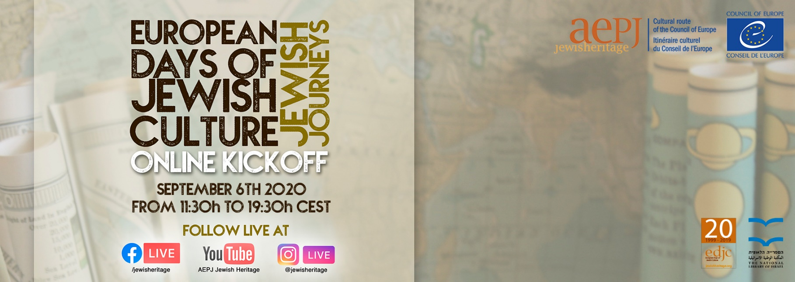

On the opening day of the European Days of Jewish Culture, an eight-hour online program will be held, open to the entire public.

The AEPJ has promoted, together with the network of participating institutions, an edition that will be based on new technologies and the digital world, giving the opportunity to reach a wider audience worldwide. In this way, for the first time in 20 years, on the opening day of the Festival, an eight-hour online program will be held, open to the entire public, where conferences, interviews, concerts and videos on European Jewish heritage will take place, offering a unique look, from the inside, at the history and Jewish communities of a large number of European participating countries. We will connect live with Luxembourg, Barcelona, Jerusalem, Paris and Oxford.

The broadcast will have six main events, detailed below, in which viewers will be able to interact with the speakers through the chat. During the rest of the broadcast, various documentaries and videos produced by the participating institutions will be retransmitted. The Online Kickoff will be broadcast live on the AEPJ's profiles on Facebook, YouTube and Instagram. We invite you to connect during the day and invite your community to do the same.
Program (Times indicated in Central European Summer Time - CEST)

11:30h - Concert
Cantor Michel Heymann. From the Luxembourg Sinagogue
13:00h - Lecture: Trees have roots, Jews have legs (in English).
By Jeremy Leigh, Director of RJ Scheuer Israel Seminar. From the National Library of Israel, Jerusalem.
14:30h - Lecture: A trip to the Jewish Alsace and Lorraine of the 1980s: a heritage survey (in French).
By Dominique Jarrassé, Professor of Contemporary Art History at the University Bordeaux.
16:00h - Interview: Paradigm shift? A new look at Judaism in Europe in 2020 (in Spanish).
By Marcel Dimenstein, JDC International Centre for Community Development, in conversation with Víctor Sörenssen, director of the AEPJ. From the AEPJ Headquarters, Barcelona.
17:30h - Virtual Tour: The Jewish Journey: 4000 years in 22 objects from the Ashmolean Museum (in English).
By Rebecca Abrams, journalist & author of the book "The Jewish Journey". From the Ashmolean Museum, Oxford.
19:30h - End of broadcast
During the rest of the broadcast, several documentaries and videos produced by the participating institutions will be retransmitted.
Facebook: https://www.facebook.com/jewisheritage/live/
Youtube: https://youtu.be/Vr7bSi0Bawc
Instagram: https://www.instagram.com/jewisheritage/

More about the AEPJ

The European Association for the Preservation and Promotion of Jewish Culture and Heritage (AEPJ), NGO created in 2004, is a network of European institutions, including public bodies, private foundations, federations of Jewish communities and NGO’s, that serves as a platform to develop cultural initiatives and educational programs to European Jewish sites. The AEPJ network acts as channels for intercultural dialogue and promoting better knowledge and understanding of European history, creating awareness of cultural diversity and strengthening European citizens' cultural identity.

The AEPJ serves as an organisational umbrella to welcome, promote, train and help develop unique Jewish cultural and heritage projects of excellence around Europe. A community, a network and a meeting point of professionals working in the field of Jewish Heritage. The AEPJ helps organisations develop their programs, offers training in the field of Jewish cultural tourism and exchange of good practices and promotes the development of transnational programs.

With a heritage approach in line with the Council of Europe, with its integrated and cross-disciplinary approach to cultural heritage and diversity, the AEPJ promotes fundamental European values of human rights, cultural diversity and intercultural dialogue seeking to bring the Jewish heritage closer to all European citizens, involving them in the production, circulation and conservation of Jewish culture and heritage.

