Tzedaka Evening
Nathan E Anna Cassuto Lodge – Milan, Italy
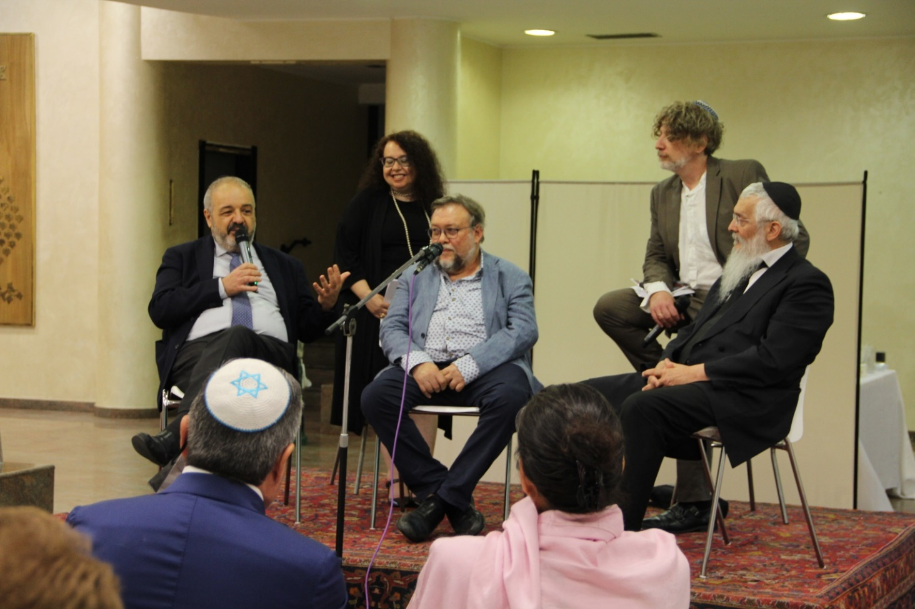
On June 13, 2022, the Milan Nathan E Anna Cassuto lodge organized an evening on the theme of Tzedaka, one of the cornerstones of B'nai B'rith's activities.
The program of the evening, hosted by actor and singer Enrico Fink and Sister Giulia Pesaro, started with the presentation of the book “Mi Yad Le Yad”; by Brother Manuel Mires.
The book is a collection of essays and parashot on the theme of Tzedakah and was intended as a gift for Bat / Bar Mitzvahs, as a guide to mutual support - a fundamental mitzvah for the Jewish people.
Followed a common reflection and discussion on ethical aspects and the significance of Tzedaka for every Jewish person. The discussion was led by the Masters Rav Alfonso Arbib, Rav Avraham Hazan and the painter Tobia Ravà – who designed the book’s cover.
The second part of the evening was dedicated to Tzedaka intended as help and support to those in need, even before there is a call for help. These were discussed by Ramesh Khordian of the Jewish Community of Milan, Rosanna Supino, of the Nanà project (Nashim le Nashim, or "women for women"), a telephone helpline for women who are in trouble or suffer from loneliness; and Rosanna Bauer, founder of the voluntary association Federica Sharon Biazzi.
The conduct by Enrico Fink endowed the meeting with light and humoristic atmosphere peppered by anecdotes and playful exchanges with the speakers. At closure he regaled us with a poignant song of the Italian Jewish tradition.

